This document is merely to point out the differences in confessional count numbers between my findings and the official numbers posted on Survivor Sucks. The guidelines I use can be found [here](https://docs.google.com/document/d/18ofsPiVWxSejzSjEGlU8KEx4Og2ddEJScCV23RsCPIA/edit?usp=sharing).

**Survivor Sucks Season 26 Counts** ([link](https://goo.gl/photos/cwJJo5rmjbnfM7pm9))

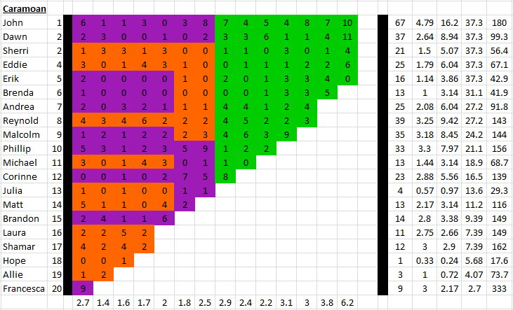

**My Season 26 Counts** ([link](https://goo.gl/photos/cwqsrSasafczHLAE8))

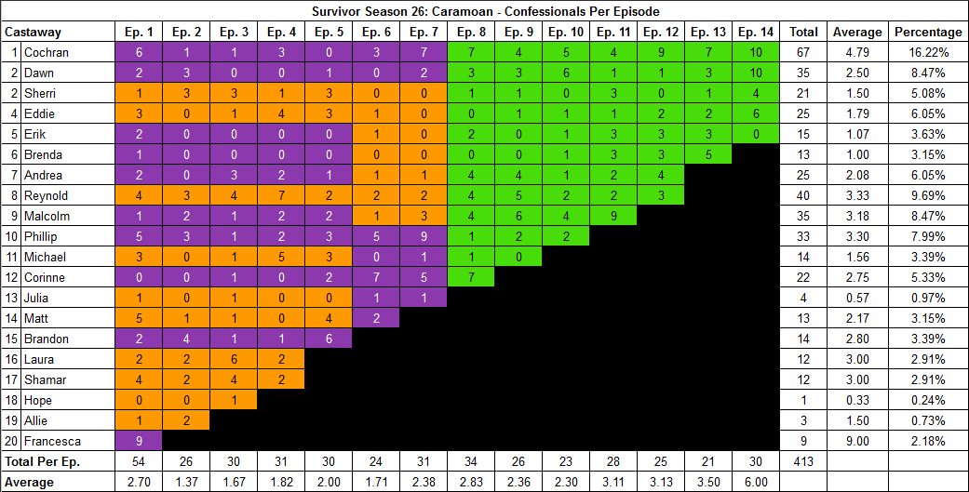

[Survivor Sucks Season 26 thread](http://survivorsucks.com/topic/102506).

**Differences**

[Episode 03](https://docs.google.com/document/d/1uYDTzYjYlJZ6pl9PuzGz83l3-qwMA_ImwN7GQBB65rU/edit?usp=sharing)

* **Laura: 6 (+1)** Confessional #4 is a voice over plus has a 12s gap with confessional #5, which is another Laura confessional.

[Episode 04](https://docs.google.com/document/d/1ZJ3qAhwL0klYohEu-hYgPzKugVcNdpSpUx04UcSb_Wg/edit?usp=sharing)

* **Reynold: 7 (+1)** Confessional #28 is a voice over that is preceded by a 10s gap from another Reynold confessional (#27).
* **Michael: 5 (+1)** Confessional #25 has a 10s gap.

[Episode 06](https://docs.google.com/document/d/19-LFsMjChXsaAs0DBqvWMTBVfcKgWpgT1LNAZ77bdGU/edit?usp=sharing)

* **Malcolm: 1 (-1)** I only counted one sole confessional (#14) for Malcolm in this episode instead of the established 2. There are no significant gaps (9-10s). It is on Day 14, post-swap on Gota, when Malcolm and Andrea sneak into jungle to talk.

[Episode 07](https://docs.google.com/document/d/1RRWtomJLqU7BDnYr11FDPwHPXDEBktkm_mZPGIlqN8c/edit?usp=sharing)

* **Cochran: 7 (-1)** Confessional #25 has a 9s gap.

[Episode 08](https://docs.google.com/document/d/1GeyMKIQoC9MMdBP0EqT91dQn8gTPkN0kofsMWmnPPBs/edit?usp=sharing)

* **Corinne: 7 (-1)** Confessional #3 has a 9s gap.

[Episode 10](https://docs.google.com/document/d/1fbN9zHDq-mqawO5ZEF388duhPnJaqP2xf3_am0wgSl8/edit?usp=sharing)

* **Malcolm: 4 (+1)** Confessional #19 has an 11s gap.

[Episode 12](https://docs.google.com/document/d/1_CN0GKGPPkbPyTq8SudoJyNildJkYQu8LambkRuI1d4/edit?usp=sharing)

* **Cochran: 9 (+1)** Confessional #12 has a 12s gap.

[Episode 13](https://docs.google.com/document/d/1HJkFqWDY-rg_yxvjBqnzYMo-mQTpri9cMStnp5AqtNs/edit?usp=sharing)

* **Dawn: 3 (-1)** Dawn has two confessionals in which both of them have 9s gaps. These contributed to bringing her count by one. The confessionals are #3 & #11.
* **Erik: 3 (-1)** Confessional #5 has a 9s gap.

[Episode 14](https://docs.google.com/document/d/1v1OGr-bH83jznZLRR-WHOTaGuF8wMBSX1_r19r_tuyg/edit?usp=sharing)

* **Dawn: 10 (-1)** I only counted 10 confessionals for Dawn instead of the established 11. The only significant gap comes in #28 which has a 10s gap.

**No Change**

* [Episode 01](https://docs.google.com/document/d/1K7lfA5Z0MVhqmYYelUNuxf_n3YA5iohzf6emlz74QM4/edit?usp=sharing)
* [Episode 02](https://docs.google.com/document/d/1xnYgwRICbL0hYH3tOL5ElzC2jEo_8yPjIqMTz65FBw8/edit?usp=sharing)
  + The only way for Phillip to have the established 3 confessionals is to include the following two:
    - Confessional #15 starts with a Phillip confessional interview and transitions into him being with Malcolm and talking directly to the camera.
    - Confessional #17 is said by Phillip to the camera as he introduces all of ‘Stealth-R-Us.’
  + Confessional #25 has elements of ‘on the fly’ at the beginning as Reynold finds the HII and talks directly to the camera, and then transitions into an interview. No significant gap in this transition. I included him reading the clue but it doesn’t affect the count.
* [Episode 05](https://docs.google.com/document/d/1-y991SCrGKevK6EujEEW9jzXSihGSDYV6pLW3OWWAxY/edit?usp=sharing)
  + As Gota searches for the HII, almost towards the end of Matt’s confessional #11, there is an instant that Reynold looks directly at the camera and briefly says, *“Oh, that so looked like it.”* Some may consider that as an ‘on the fly’ and include it as part of his count. I personally didn’t.
* [Episode 09](https://docs.google.com/document/d/1qJYT9MoUFGIBc7PC50wEcfpTuos0GU6eG-fNIDkl-5Q/edit?usp=sharing)
* [Episode 11](https://docs.google.com/document/d/1e1JSGOLDi5nzP3dD7vWFV-ImDh1RalcOKd8vVv158KY/edit?usp=sharing)

|  |  |  |
| --- | --- | --- |
| **Castaway** | **Count** | **Change** |
| Laura | 12 | +1 |
| Corinne | 22 | -1 |
| Michael | 14 | +1 |
| Malcolm | 35 | - |
| Reynold | 40 | +1 |
| Erik | 15 | -1 |
| Dawn | 35 | -2 |
| Cochran | 67 | - |
| **Total** | **413** | **-1** |

**Revised Sucks Counts** ([link](https://goo.gl/photos/E6vQZbec3F3Ctsre9))

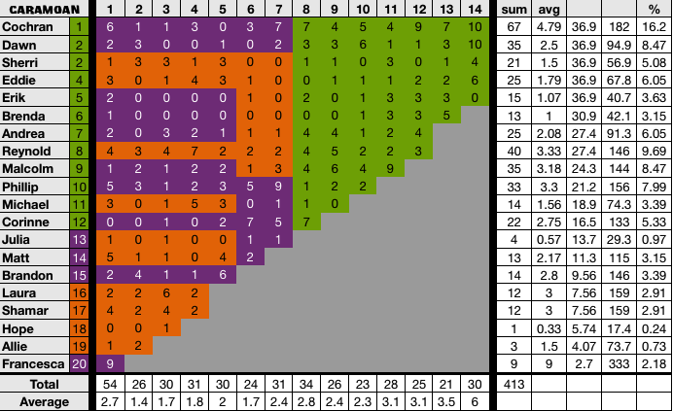

**Differences:** None. All my findings are reflected in the verified counts.